**Template Week 5 – Operating Systems**

Student number: 588406

**Assignment 5.1: Unix-like**

1. Find out what the difference is between UNIX and unix-like operating systems?

* UNIX is the original operating system that is officially licensed. UNIX-like operating systems are similar to the UNIX operating system but are not officially licensed.

1. Study the image above named UNIX timeline. Find out who Ken Thompson, Dennis Ritchie, Bill Joy, Richard Stallman, and Linus Torvalds are and what they have contributed to the development of UNIX or unix-like systems and to IT in general. **TIP!** English-language sources often contain more detailed information about these individuals.

* Ken Thompson developed one of the first versions of the UNIX operating system, Dennis Ritchie developed the UNIX system and designed the C language, Bill Joy developed BSD UNIX and many essential UNIX utilities, Richard Stallman initiated the GNU project, which advocated free software, and Linus Torvalds developed the Linux kernel on which many UNIXes are based.

1. What is the philosophy of the GNU movement?

* The ideology of the GNU movement argues that software should be free and allow anyone to use it, study it, modify it, and redistribute it.

1. Does Ubuntu as a Linux operating system conform to the philosophy of the GNU movement? Please explain your answer.

* Yes, Ubuntu has remained largely true to the ideals of the GNU philosophy in that it is free and open-source software whose source code can be examined, modified, and redistributed despite containing optional non-free software.

1. Find out what is the Windows Subsystem for Linux?

* Windows Subsystem for Linux, or WSL for short, is a feature of the Windows operating system developed by Microsoft. It allows users to execute Linux commands within the operating system without needing to install Linux alongside Windows.

1. Find out, which operating system family belongs to Android, iOS and ChromeOS?

* The Linux family also includes Android. The UNIX family also includes iOS. The Linux family also includes ChromeOS.

**Assignment 5.2: Supercomputers and gameconsoles**

1. Research on this site what supercomputers are used for and write a short summary of it: <https://www.computerhistory.org/timeline/search/?q=Supercomputer>

* Supercomputers are highly advanced computers that help solve large and complex problems, beyond the capability of other regular computers, and are employed by researchers for the execution of weather forecasting, scientific simulations, analysis of big data, and scientific studies in the fields of medicine and engineering.

1. IBM is a company that has already built a number of supercomputers. One of them is IBM's Roadrunner. The CPU developed for this supercomputer was further developed at a later stage as the CPU for the PlayStation 3 console. Find out what a **PlayStation 3 cluster** is and what it was used for?

* A PlayStation 3 cluster is a set of PlayStation 3 consoles networked to function together as a mini supercomputer, and this was primarily for scientific research purposes such as simulations and data processing since supercomputers are quite pricey relative to the Cell processor of the PlayStation 3.

1. You can build a supercomputer by putting a few computers together in a cluster. Here's what Oracle did with a collection of Raspberry Pi's, for example: <https://blogs.oracle.com/developers/post/building-the-worlds-largest-raspberry-pi-cluster> What specific operating system is running on this cluster?

* The Raspberry Pi cluster that Oracle has established supports Oracle Linux, an implementation of Linux, on all of the Raspberry Pi computers.

1. Does Oracle's Raspberry Pi supercomputer appear in the list of the 500 fastest supercomputers in the world? Make a logical decision for this, without going through the entire list. <https://www.top500.org/lists/top500/list/2023/06/>

* Oracle's Raspberry Pi-themed supercomputer wouldn't make it to the list among the world's 500 fastest supercomputers because the world's Top500 list only holds the world's most powerful supercomputers with incomparably high calculating power, while Oracle's Raspberry Pi supercomputer is just too slow to compete with actual supercomputers.

1. What CPU architecture is used for the PlayStation 5 and Xbox Series X?

* The PlayStation 5 and Xbox Series X feature an x86-64 (AMD Zen 2) CPU architecture.

What operating systems run on these consoles?

* PlayStation 5: It has its own operating system built on FreeBSD. The Xbox Series X console runs its own operating system built on Windows.

What conclusion can you draw from the answer to the previous question?

* The PlayStation 5 has an operating system that is based on FreeBSD. The Xbox Series X has an operating system that is based on Windows.

**Assignment 5.3: Working with Windows**

**Take relevant screenshots of the assignments below**

1. Practice for about 10 minutes with the W keyboard shortcuts combinations, skip the general shortcuts in this exercise. Take a look at which screens are opened.
2. The file explorer can be opened with W + E, Which key combination could you also use?

Windows + R, then type explorer and press Enter

1. Open the system properties with a W key combination, take a screenshot of the open screen. Paste this screenshot into this template.

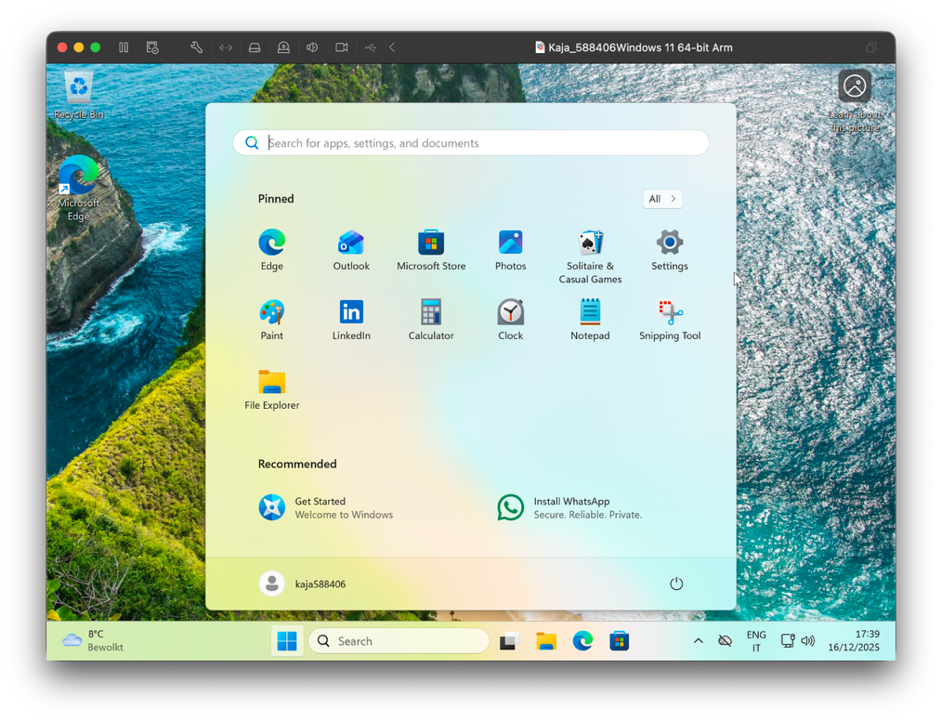

1. Open task manager with a key combination. Take screenshots of the tabs: processes (shows active processes), performance, and users. Place these three screenshots in this template.

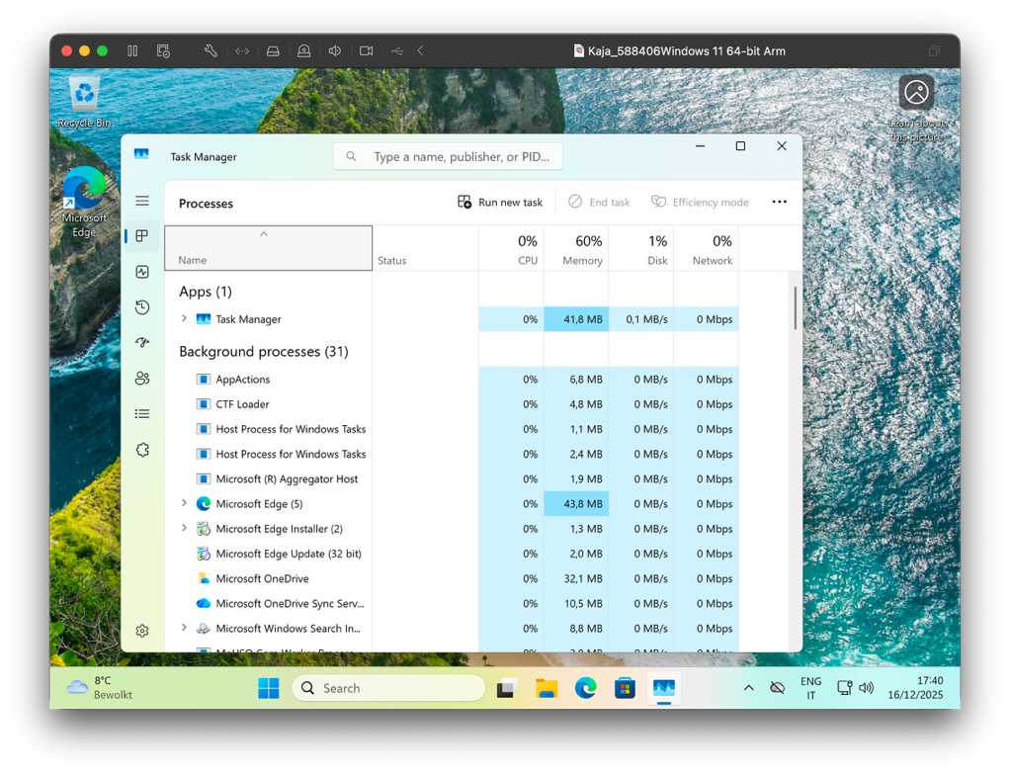

1. If you're giving a PowerPoint presentation and you connect your laptop to a projector, Windows can use the projector as a second screen. For example, you may have Outlook open on your first screen that you don't show over the projector, while the PowerPoint presentation is displayed on the projector, or the second screen. Which key combination should you use for this?

Windows key + P

1. If you leave the classroom for a while and you leave your laptop behind, it is wise to lock the screen. Your Apps will continue to run in the background. So, for example, if you're waiting for a download that takes a while, lock the screen and get a cup of coffee. Which key combination do you use for this?

Windows key + L

1. Open the Run screen with a key combination. On this screen, type CMD and press <enter>. Take a screenshot of this result and paste it into this template.

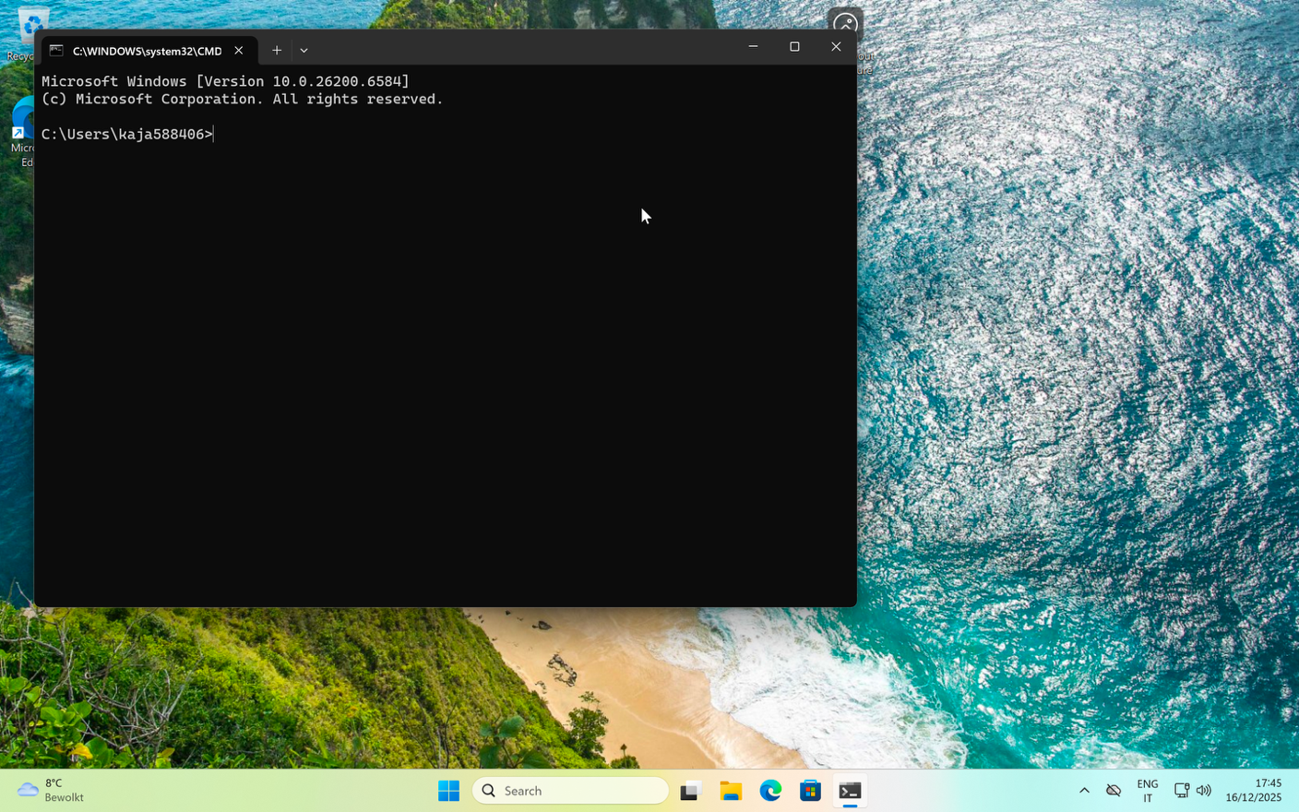

**Working in the File Explorer**

Relevant screenshots **copy** command: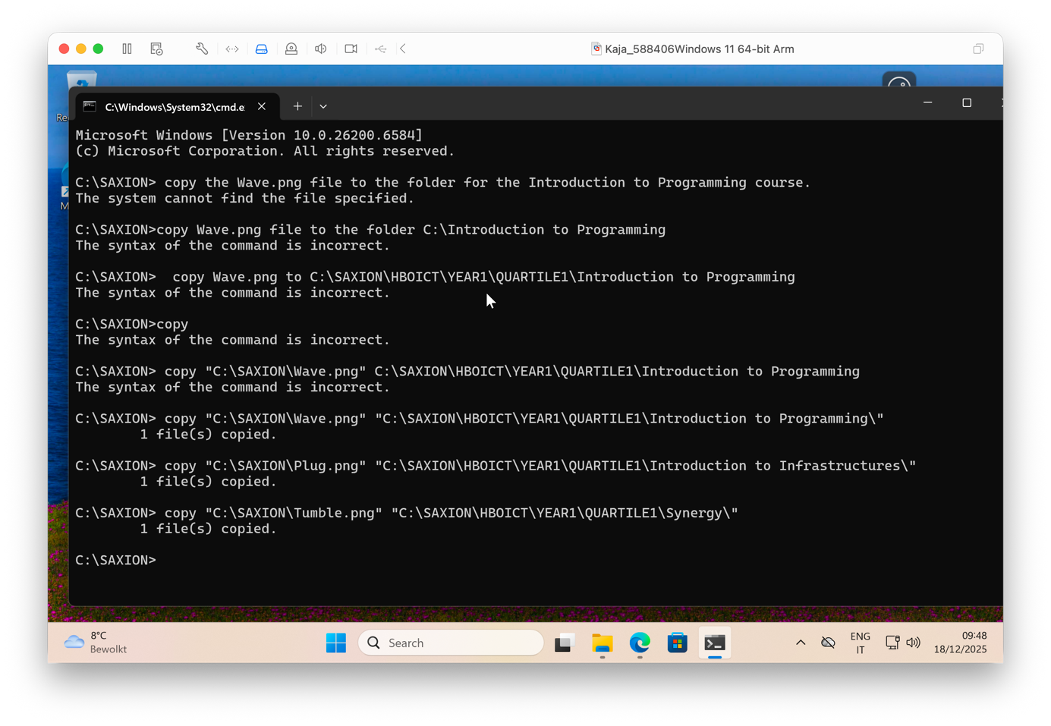

Relevant screenshots **tree** command:

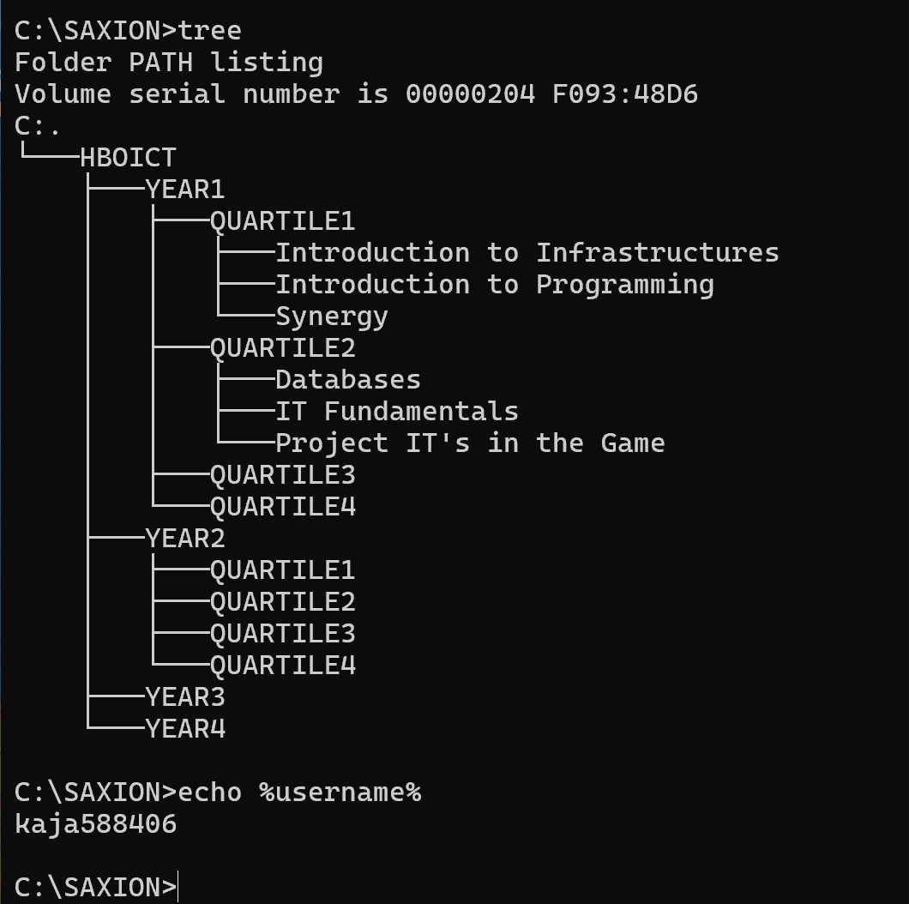

Relevant screenshots in the file explorer of the folder c:\Saxion + created zip file. 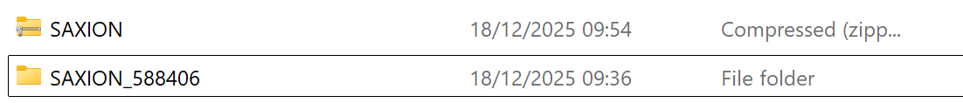

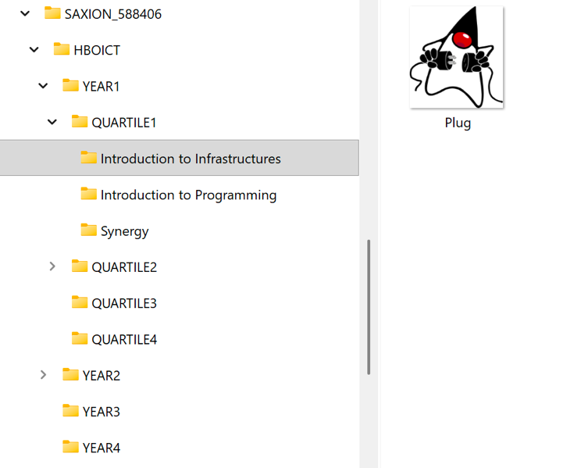

**Terminating Processes**

Relevant Screenshots Task Manager Window:

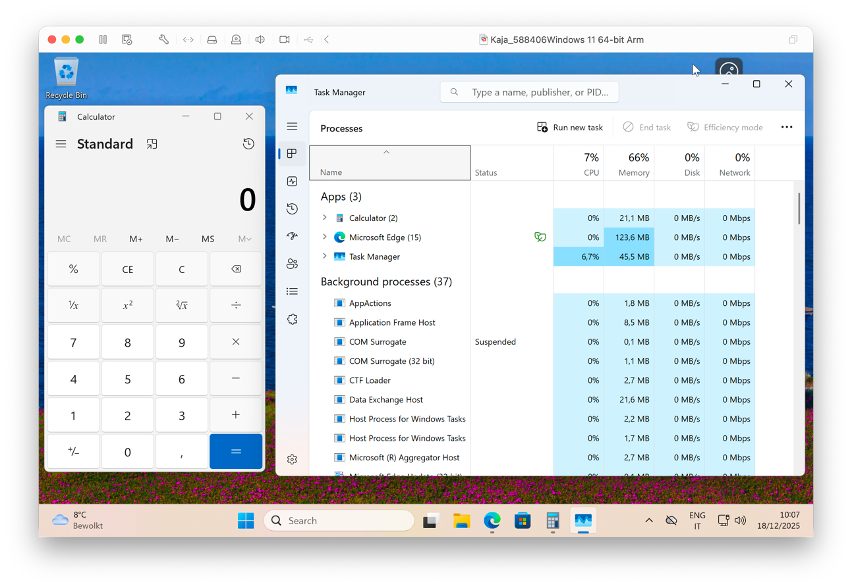

**Install Software**

Relevant screenshots that the following software is installed with winget:

* WinSCP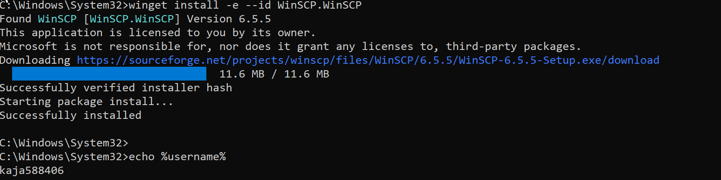
* Notepad++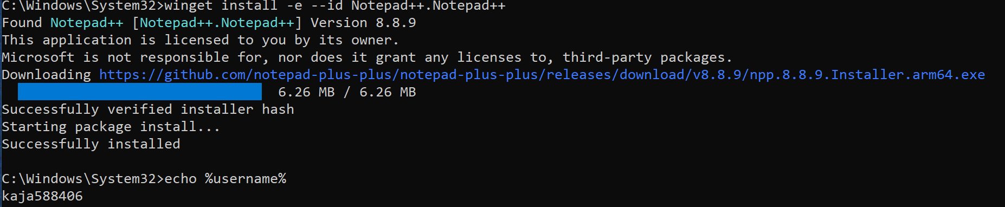
* 7zip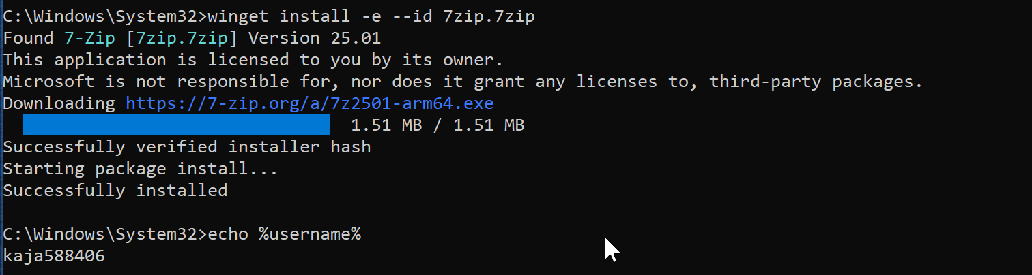

**Assignment 5.4: Working with Linux**

Relevant screenshots + motivation

* Proof that my file exist myfile.txt

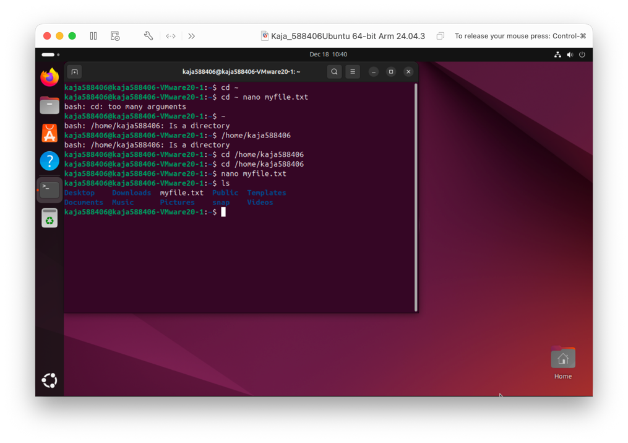

* Copying files

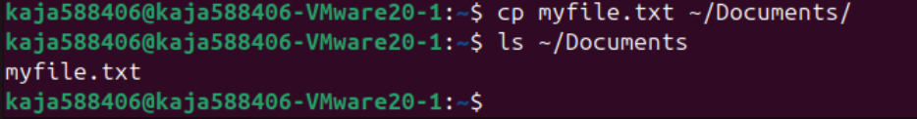

* Navigating the file structure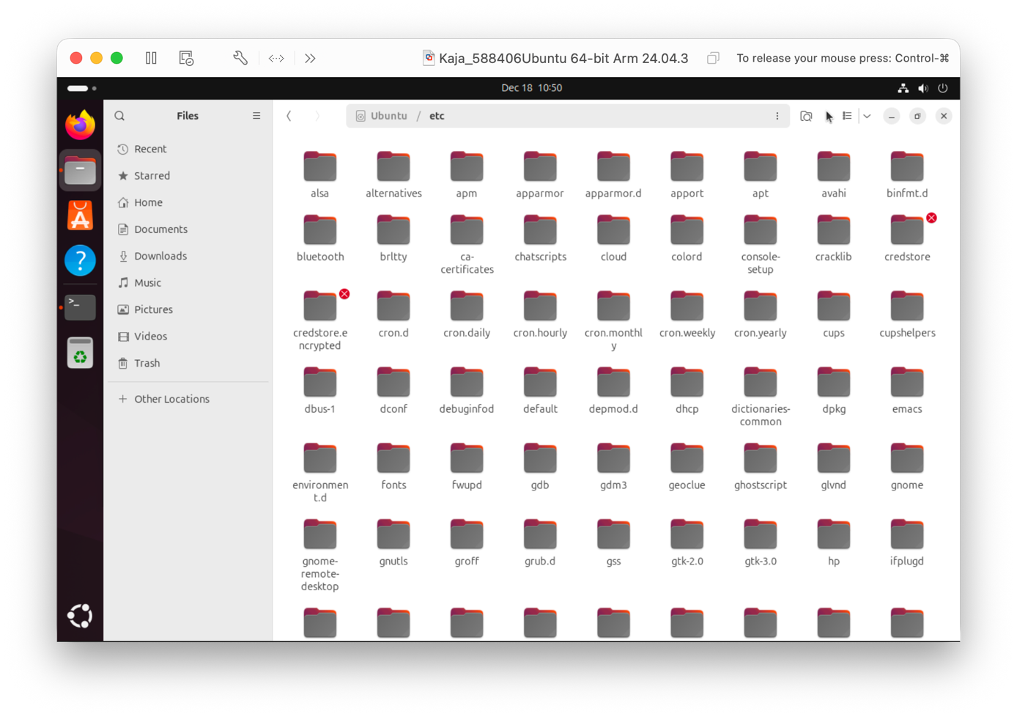

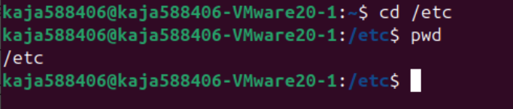

* How to get back to your home folder in the terminal?
  + by typing the command : cd ~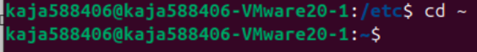
* Name one significant difference in Linux's file structure when comparing it to Windows.
  + Linux has a single directory tree starting at /, while Windows uses separate drive letters like C:\, D:\.
* What is the /etc directory usually used for?
  + It stores system-wide configuration files for the OS and services.

Compress files

* Which command in the terminal would you use to compress a text file into a tar archive?
  + tar -cf archive.tar file.txt
* With which command in the terminal would you be able to extract a tar file?
  + tar -xf archive.tar|

Compress a text file in a tar archive and compress it with gzip.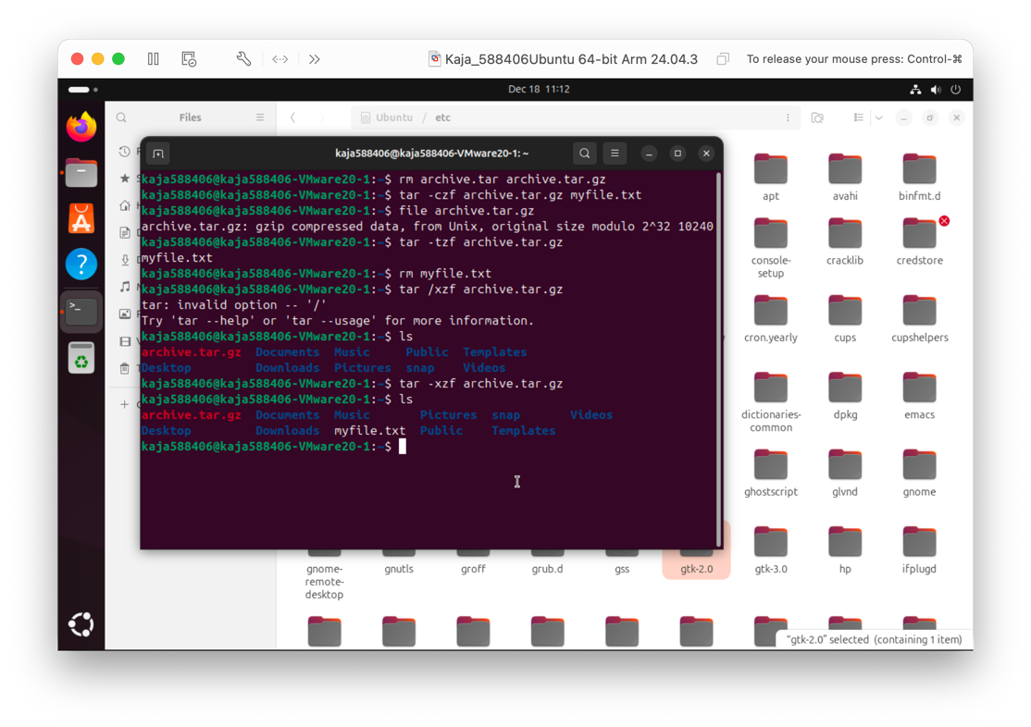

htop is an interactive process viewer that shows running processes in real time along with CPU and memory usage.

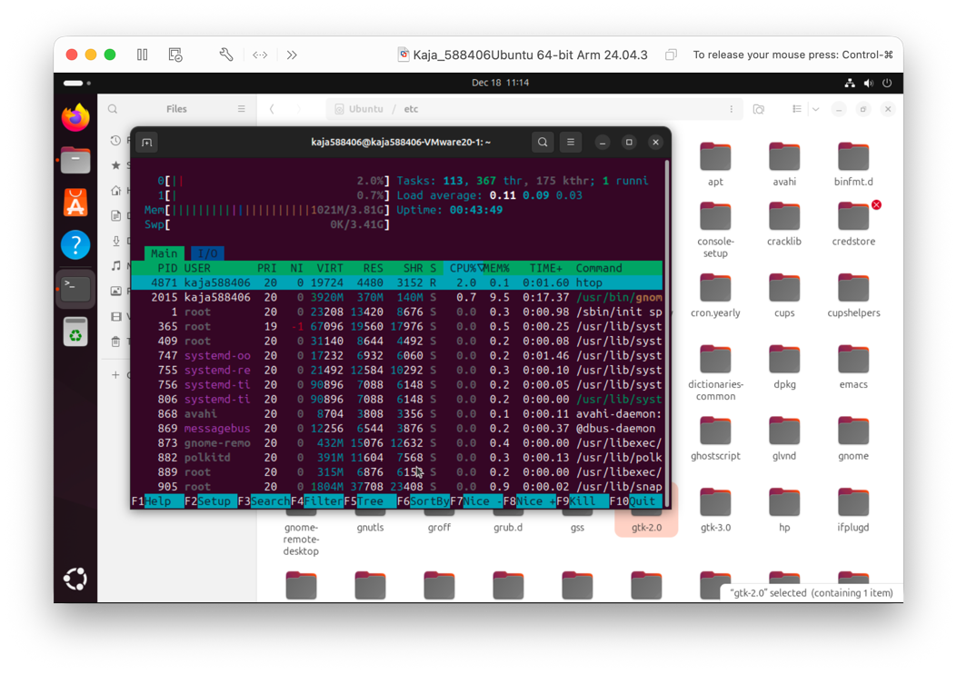

What does this application show when you launch it?

* When launched, **neofetch displays system information** such as the operating system, kernel version, CPU, RAM, and desktop environment, usually alongside an ASCII logo.

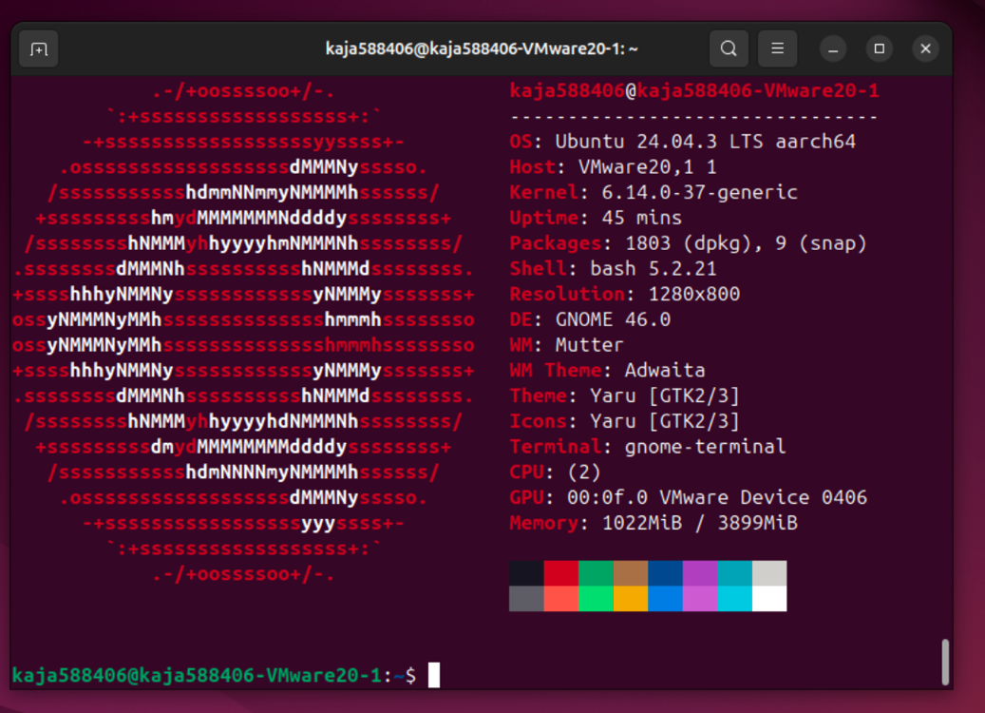

**Assignment 5.5: Users and permissions on Linux**

Relevant screenshots + motivation

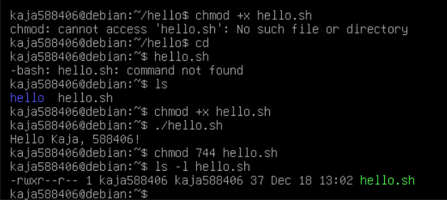

**Motivation**

This exercise introduces basic Linux file management and permissions. Creating and executing a shell script shows how text files can become programs, while using chmod demonstrates how execution rights are controlled in a multi-user system. Restricting execution to the file owner highlights the importance of security and the principle of least privilege.

**Assignment 5.6: View the contents of files**

Relevant screenshots + motivation

What does each of these commands do? Write it out for yourself.

* Cat - Shows the content of a file on the terminal.
* wc - Counts lines, words, and characters in a file.
* less - Lets you view a file page by page (scroll up and down).
* tail - Shows the last lines of a file.
* head - Shows the first lines of a file.
* Grep - Searches for a specific word or pattern inside a file.

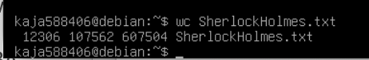

* How many lines does the file have?
  + 12306 lines 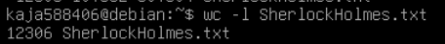
* How many words?
  + 107562 words 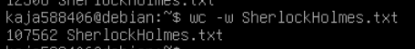
* And how many characters?
  + 607504 characters 
* On which lines is the word "kingdom" in the file?
  + On lines 490 and 1124 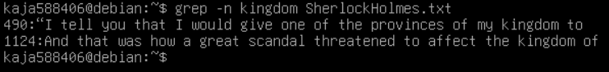
* Use the head and/or tail commands to see the 10 lines above and below the word "kingdom" on the screen.
  + Word kingdom on the line 490 + 10 lines 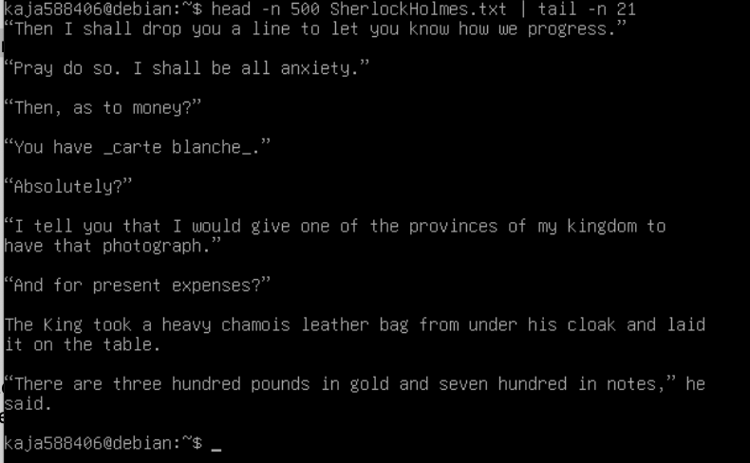
  + Word kingdom on the line 1124 + 10 lines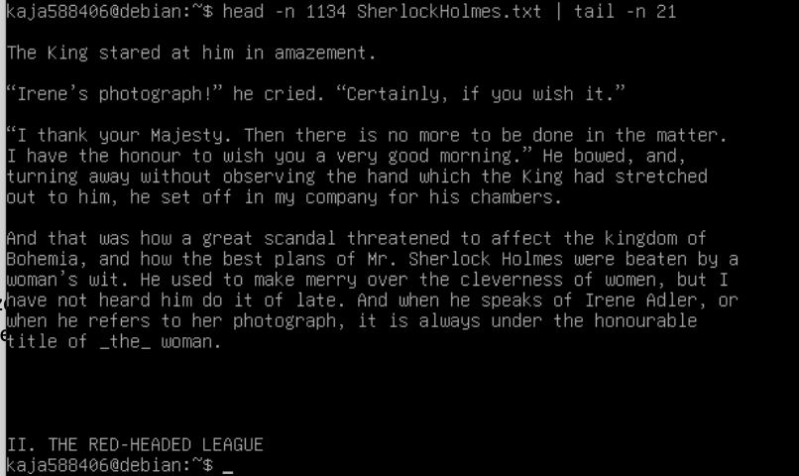

**Assignment 5.7: Digital forensics**

Relevant screenshots + motivation

* EXIF
  + Identify phone brand/type
    - Brand: Mototola
    - Type: Moto G(6) Play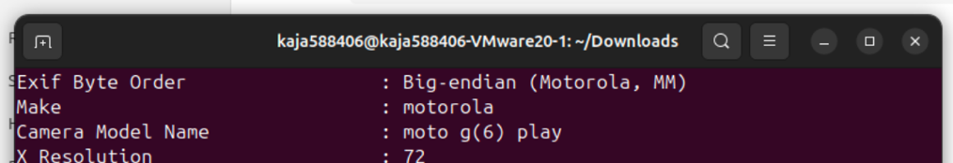
  + In which city was this photo taken?
    - The picture was taken in Groningen, The Netherlands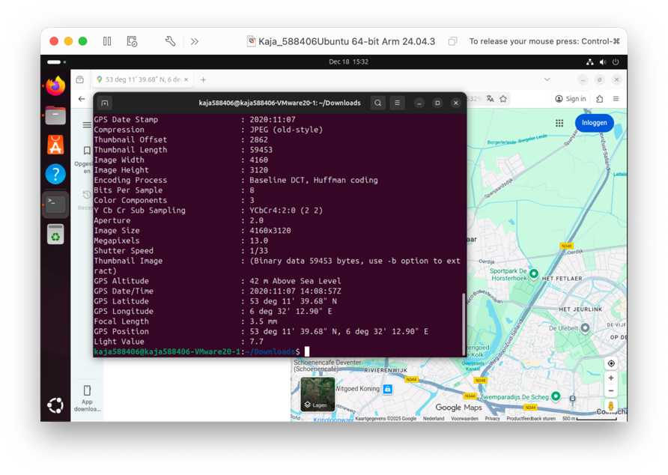
* Filename extensions
  + Rename the file to oldcar. (So you've removed the file extension)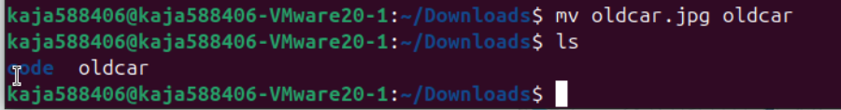
  + **Yes.** Ubuntu still recognizes it as a JPEG file because it checks the file’s content, not the file extension. 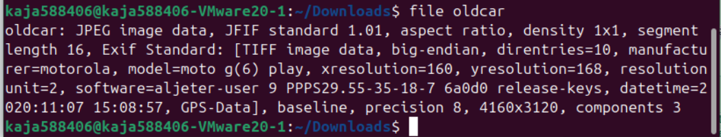
* BASE64
  + 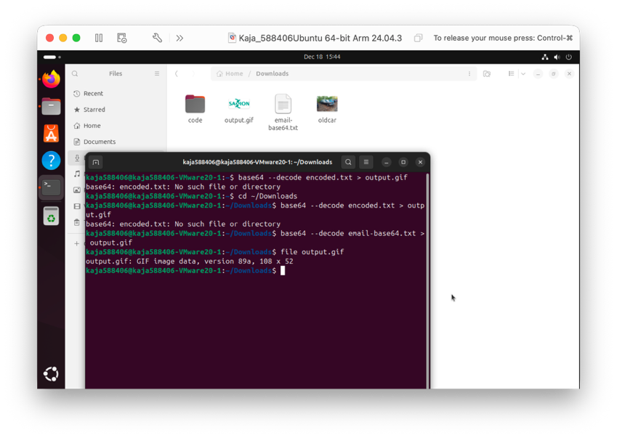

**Assignment 5.8: Steganography**

Relevant screenshots + motivation

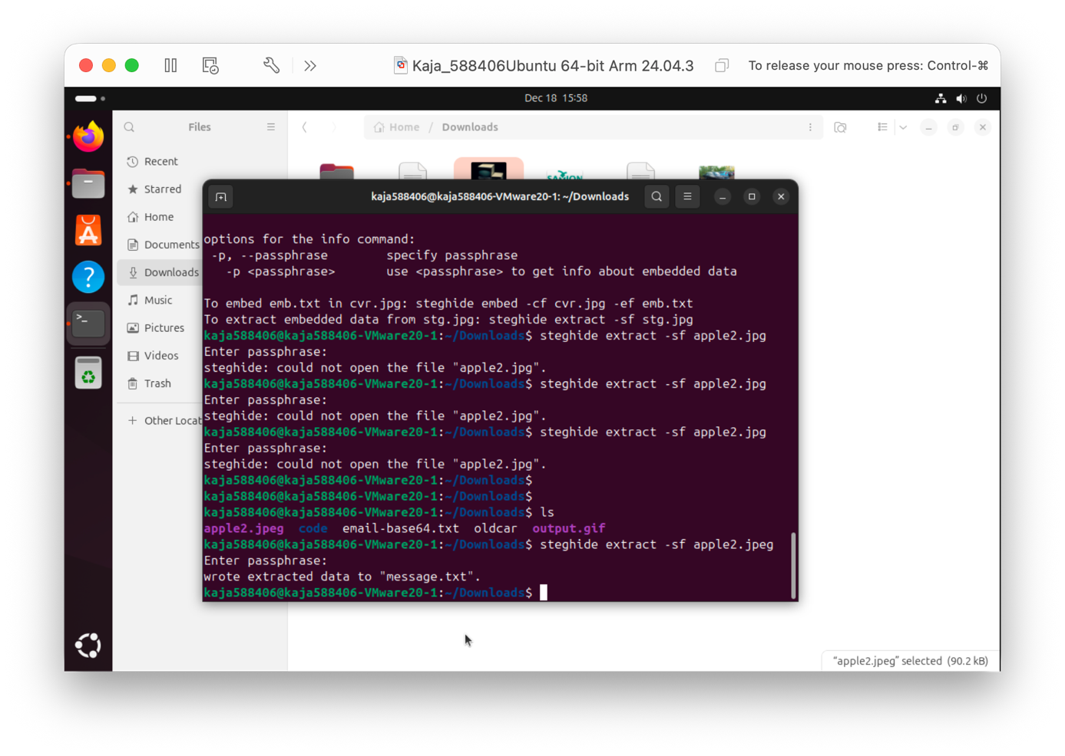

**Motivation**

This task shows how hidden data can be stored and extracted from images using steganography, highlighting the role of command-line tools in digital forensics.

**Assignment 5.9: Capture disk images**

Make relevant screenshots + motivation:

* Update the server and install SSH

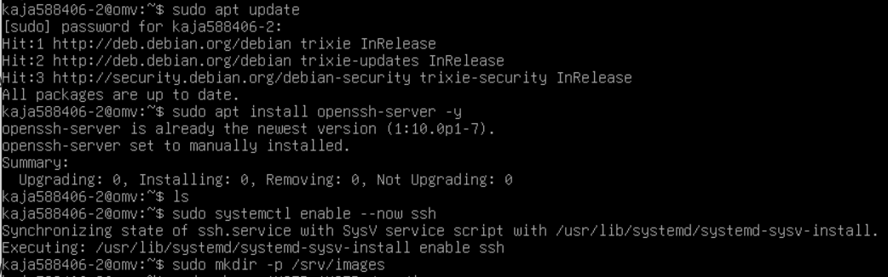

* Create a directory for images

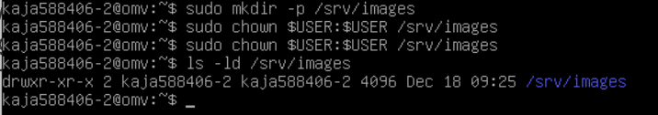

* Find your server’s IP address

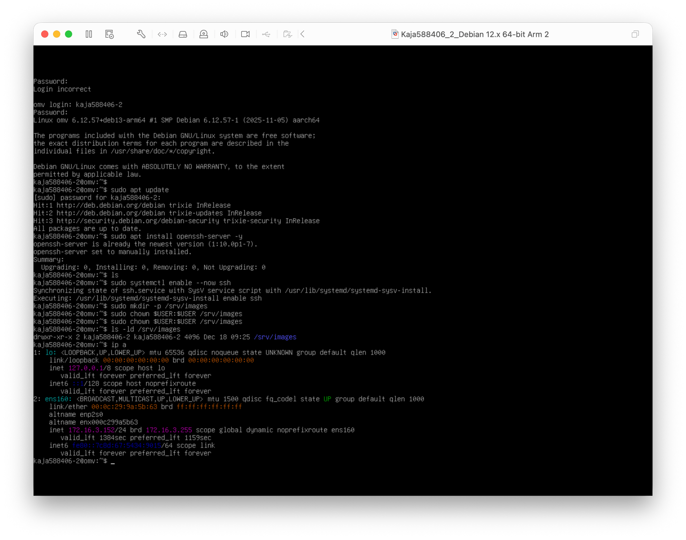

* + The IP is: Inet 172.16.3.152/24
* Test SSH connectivity from another VM

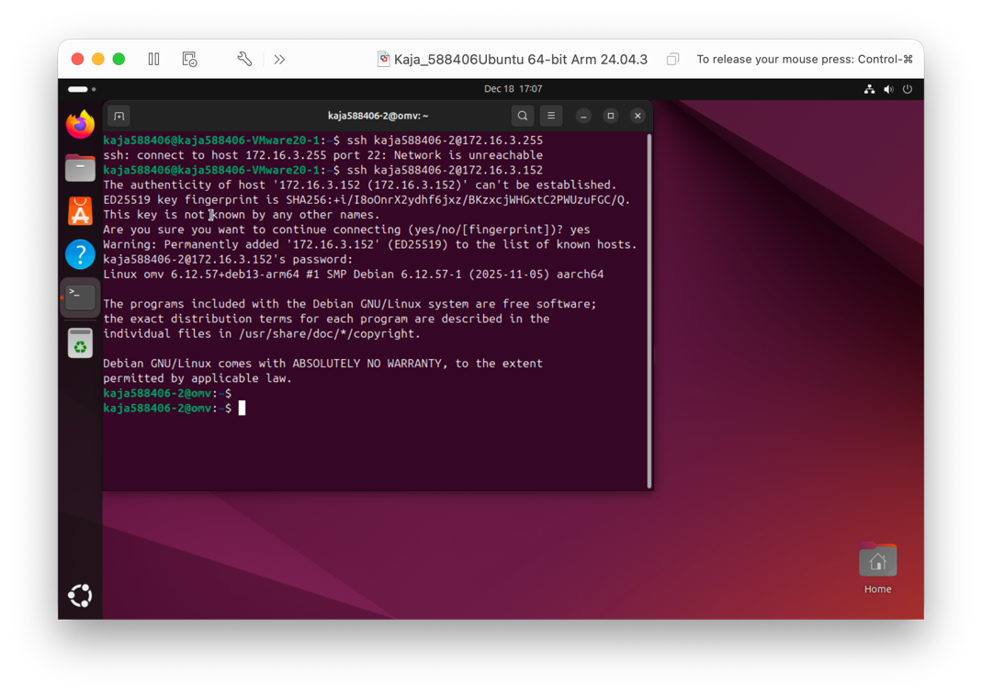

* Identify the Ubuntu desktop d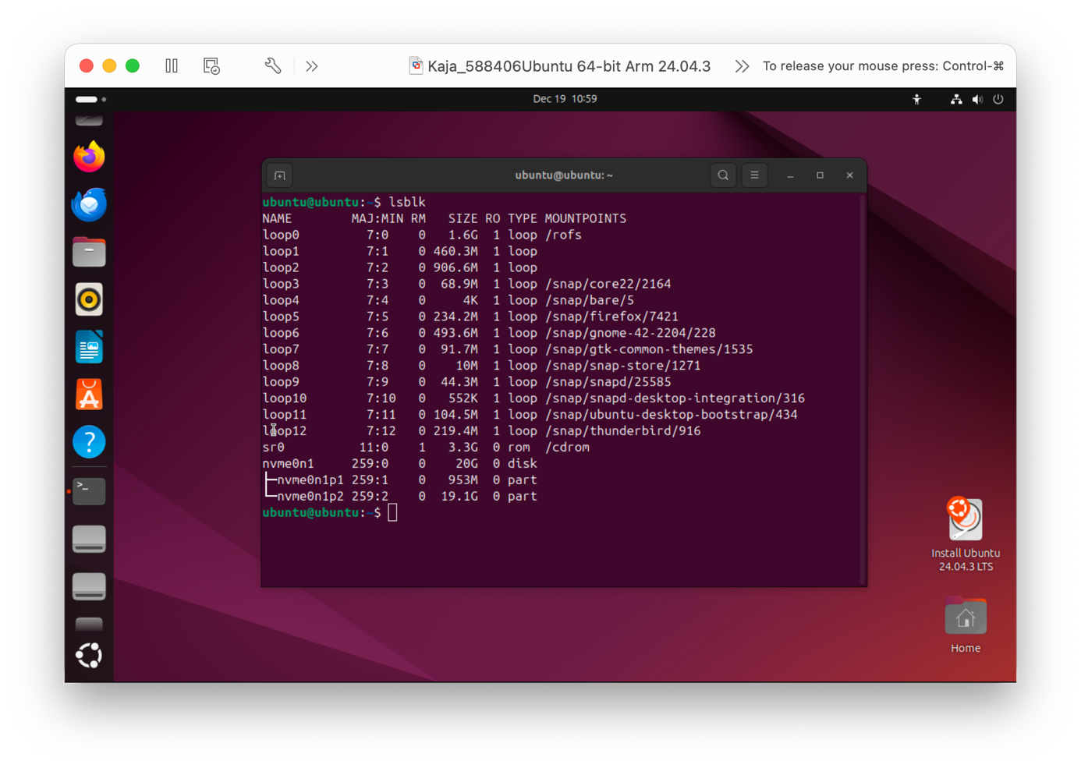
* Start the capture process
* 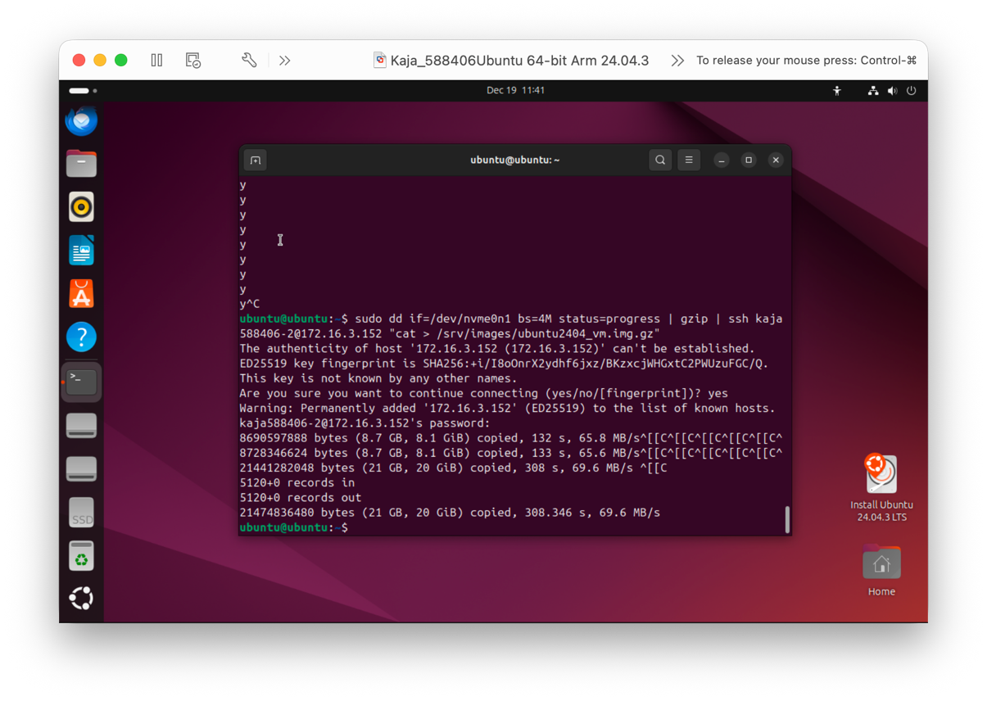

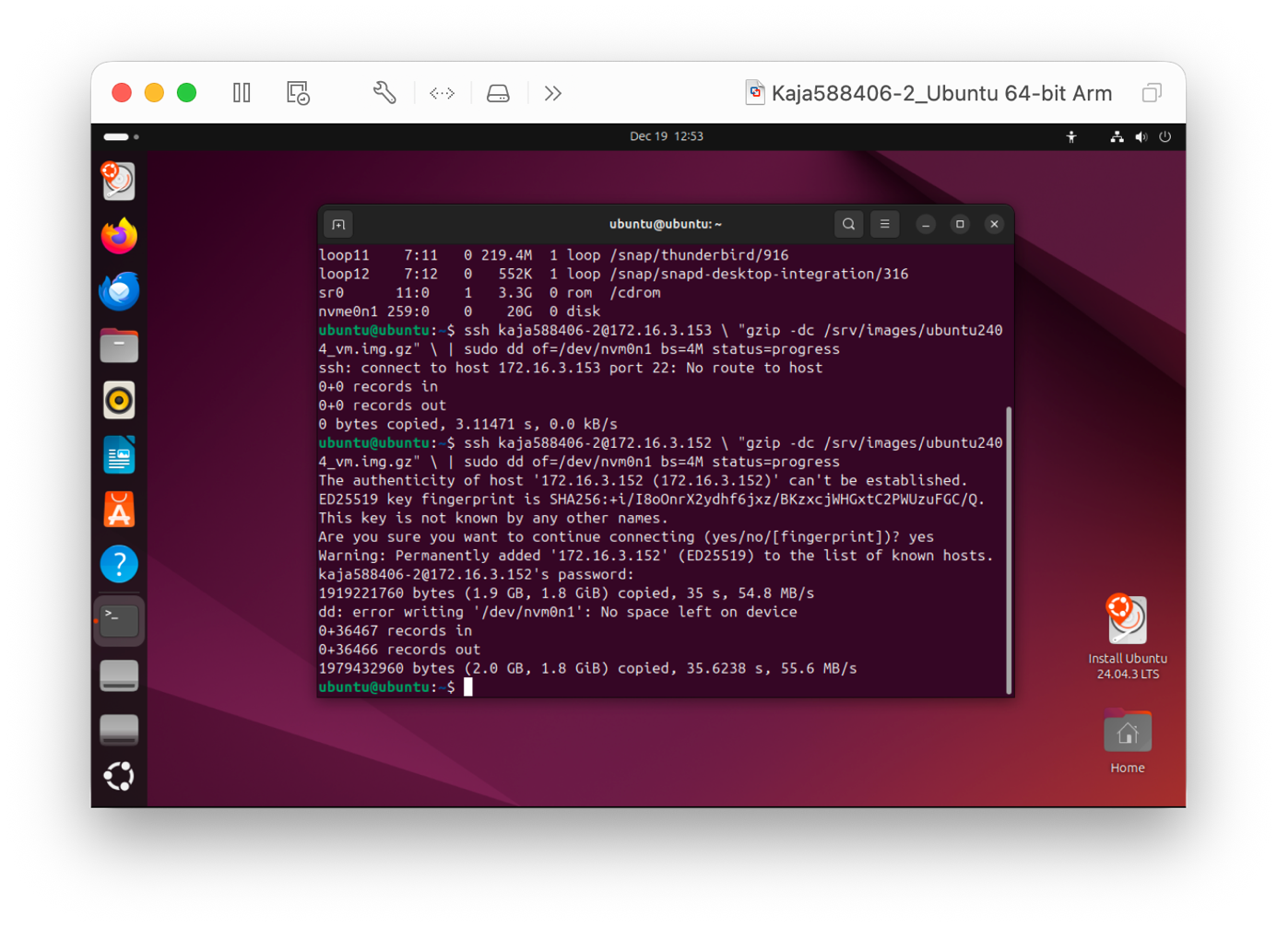

* Proof that the Debian 13 server stored a back-up image of the Ubuntu 24.04 Desktop VM. 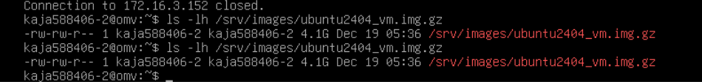

Motivation: The Debian 13 server contains a compressed disk image of the Ubuntu 24.04 Desktop virtual machine. The file ubuntu2404_vm.img.gz is stored in /srv/images and has a size of 4.1 GB, confirming that a full VM backup was successfully created.

* Proof that you can restore the back-up image into an empty VM.

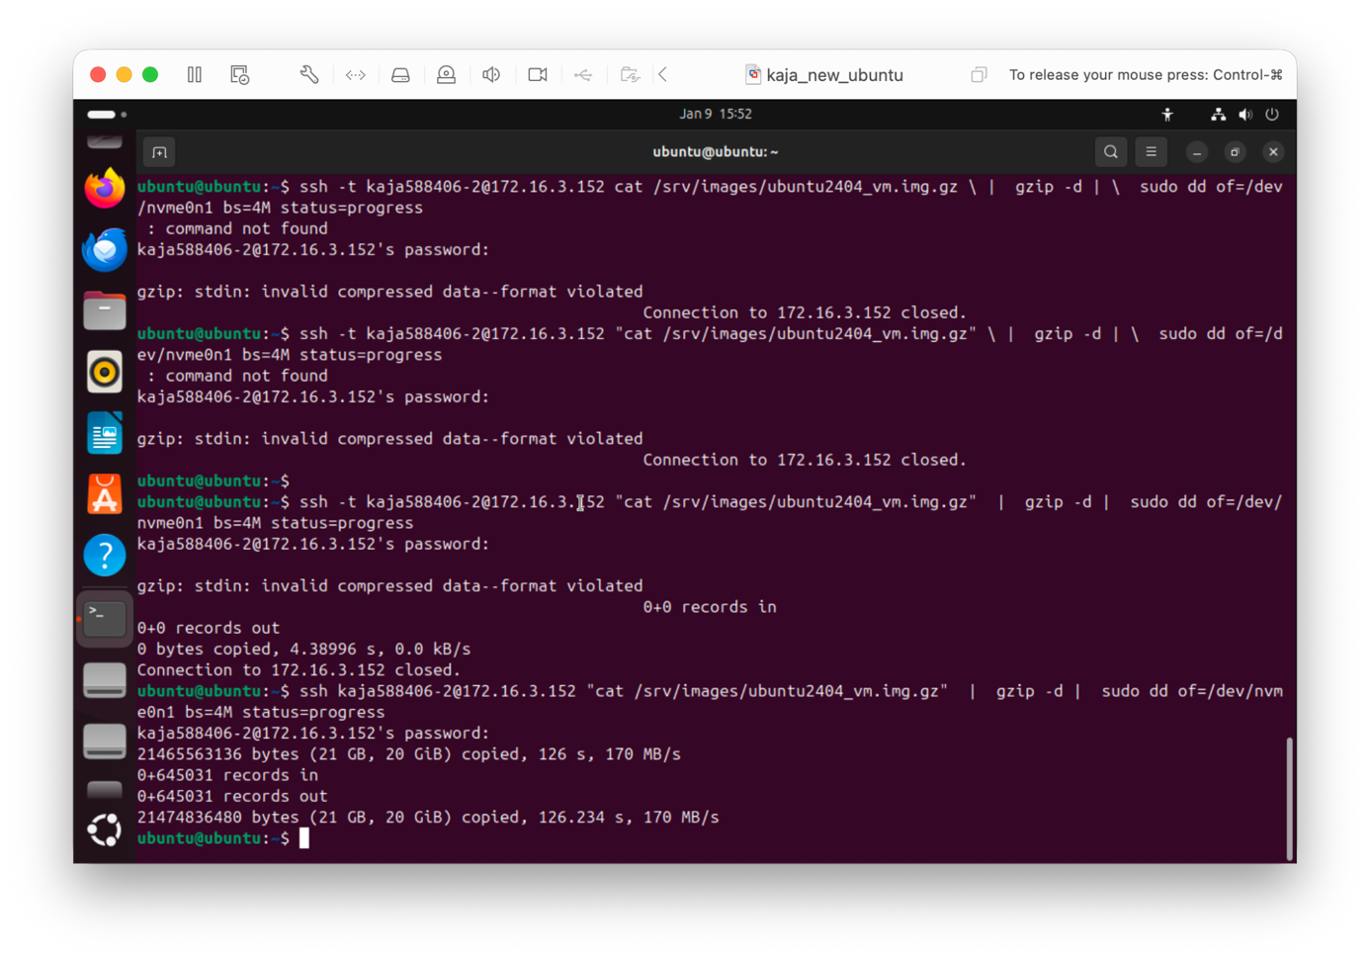

Motivation:  
The Ubuntu 24.04 Desktop image was restored from the Debian 13 server to an empty virtual machine. The terminal output shows that 21 GB was written to the virtual disk (/dev/nvme0n1), which confirms the restore was successful.

Ready? Save this file and export it as a pdf file with the name: **week5.pdf**